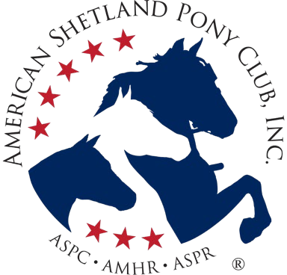
AMERICAN SHETLAND PONY CLUB, INC.

American Shetland Pony Registry • American Miniature Horse Registry • American Show Pony Registry
81-B East Queenwood Road Morton Illinois 61550 Phone: 309-263-4044 Fax: 309-263-5113 www.shetlandminiature.com

Mare Designation Form
With Resulting Foals to Show in
ASPC 2025 Classic Weanling Sweepstakes Classes
Mare Designation and DNA sample submission due May 1, 2025

Auction stallion: ____________________
Designated Mare: _____________________________ ___________
ASPC Registered Name ASPC Registration Number
If you are the stallion owner and were also high bidder, include 2nd mare here:
(Second) Designated mare: ____________________ ___________
ASPC Registered Name ASPC Registration Number
Mare Owner/Lessee: ________________________________________
Address: __________________________________________________
Street City State Zip
Phone: ______________________________ Email: ___________
All breeding arrangements are between the stallion and mare owners. ASPC/AMHR/ASPR receives no part of those fees and is not responsible for disputes arising from or connected with the breeding, as set forth in the 2024 ASPC Stallion Classic Sweepstakes: Stallion Nominations & Mare Designations; Rules & Forms.
By designating your mare and engaging in the Sweepstakes program, you agree that your participation is subject to entitlement to the breeding (high bidder or stallion owner entitled to a breeding herein). You agree that you and your agents/employees/heirs and assigns are bound by program rules as set forth in the 2024 ASPC Stallion Classic Sweepstakes: Stallion Nominations & Mare Designations; Rules & Forms available via ASPC/AMHR/ASPR), the ASPC/AMHR/ASPR accounts receivable policies and the Rule Boo, all incorporated by reference. You, your agents/employees/heirs and assigns are bound by all provisions of the program rules including limitations, waiver (of claims and damages), assumption of risk, and hold harmless clauses, incorporated by reference.
Read and agreed:
Mare Owner/Authorized Agent Signature______________________________ Date__________
Printed name: ________________________
Email: jill@shetlandminiature.com (Mailing address per heading. Attn: Classic Stallion Sweepstakes)

